Flight Booking Management System

1. The title page

Title of Project: Management System for Booking Flights
Python Programming Course
Monitor: CLI Project

2. Overview

This project is a Python-based Flight Booking Management System with a Command Line Interface (CLI). Users can effectively handle passengers, flights, and reservations thanks to the system. It shows how to employ file handling, modular programming, and object-oriented programming (OOP).
The project's primary goal is to replicate a real-world flight booking system, enabling users to engage with a terminal interface to carry out a variety of tasks like adding passengers, viewing flights, and purchasing tickets.

3. Goals

to use Python to create a flight booking system.
to put the principles of object-oriented programming (OOP) into practice.
to use CSV files for data management and storage.
to carry out CRUD (Create, Read, Update, Delete) tasks.
to enable record searching and filtering.
to produce basic reports using data that has been stored.

4. Technology Employed

Python is the programming language.
CSV files for data storage
Command Line Interface (CLI) is the interface.
Tools for development: VS Code, PowerShell, and Command Prompt

5. Design of the System

To improve organization, the project is split up into several Python modules:
Module
Main.py's purpose
Flight.py is the primary entry point that manages the menu and user interaction.
oversees passenger.py flight operations and data.
manages passenger data with booking.py
Bookings between travelers and flights are managed by utils.py
Helper features utilized during the project

Used CSV Files:
Flight data is stored in flights.csv, passenger details are stored in passengers.csv, and ticket records are stored in bookings.csv.

6. OOP, or object-oriented programming

The system makes advantage of OOP concepts to write clear, reusable code:
Passenger Class: Stands for passenger information such ID, age, and name.
Flight Class: Indicates the destination, flight number, and itinerary of a flight.
Booking Class: Oversees the connections between travelers and airlines.
The readability and maintainability of the code are enhanced by this modular structure.

7. System Features

1.Include additional passengers
ii.View the passenger's information
iii.View the flights that are available
iv.Make travel arrangements for passengers
v.Data storage and retrieval from CSV files
vi.Look up and filter records
vii.Create basic reports (bookings summary, for example).

8. Workflow of Systems

The user uses main.py to launch the program.
In the terminal, the system presents a menu.
The user chooses a choice (e.g., add passenger, view flights).
The request is processed by the system.
CSV files are used to store and retrieve data.The user sees the result.
9. Persistence of Data Storage

The system ensures that all data is saved even when the program is terminated by using CSV files for data storage. The data is automatically loaded from these files when the program is restarted.
10. Output and Screenshots (Include three to five screenshots displaying the following)

a.screen with the main menu
b.Including a new traveler
c.Looking at the list of flights
d.updating the passenger's information
e.Results of the output

11. Obstacles

utilizing several files to organize the project.
managing CSV file operations correctly.
resolving issues with Python script execution.
controlling user input to avoid crashes.

12. Conclusion

This project improved knowledge of fundamental Python ideas such modular programming, file handling, and object-oriented programming. It gave practical experience in developing a structured and maintained CLI application.

Output screenshots:

01_main_menu.png

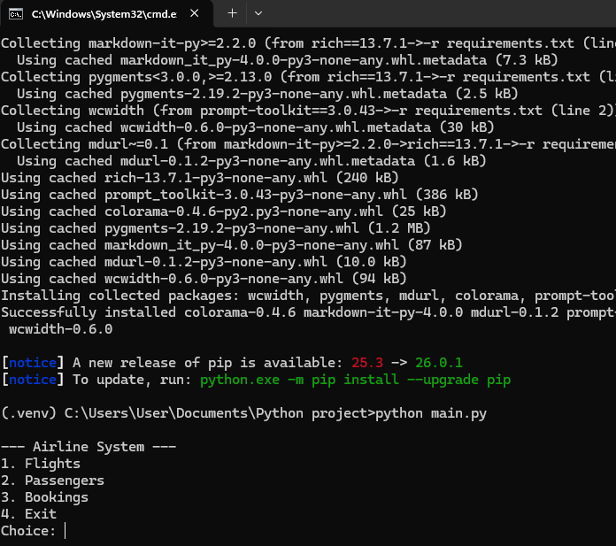

02_add_passenger.png

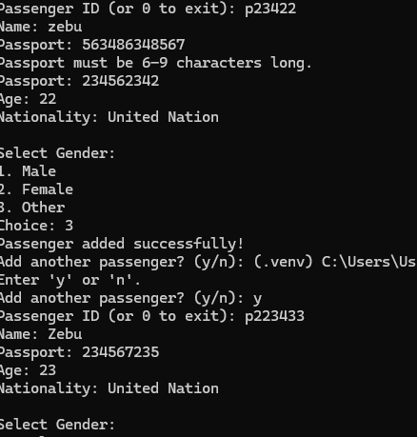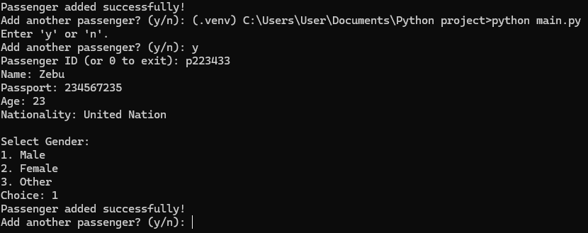

03_view_flights.png

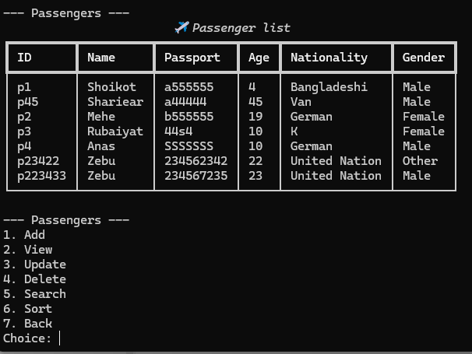

04_view_update_passenger_details.png

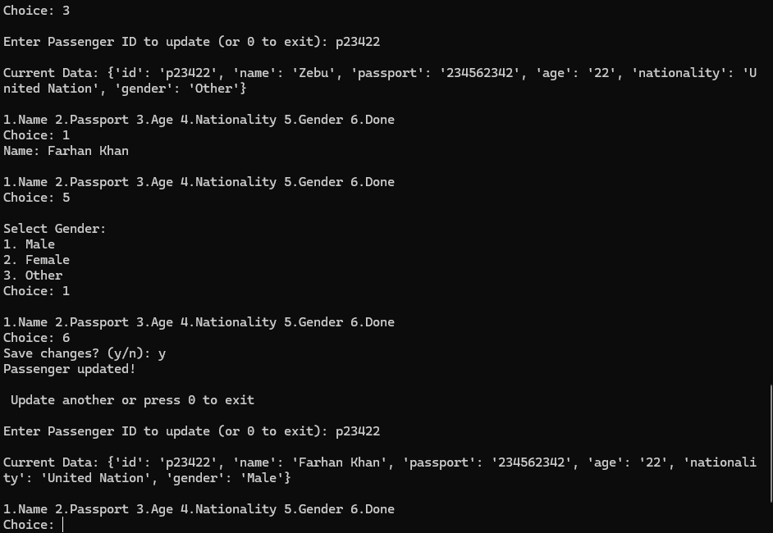

05_view_delete_passenger.png
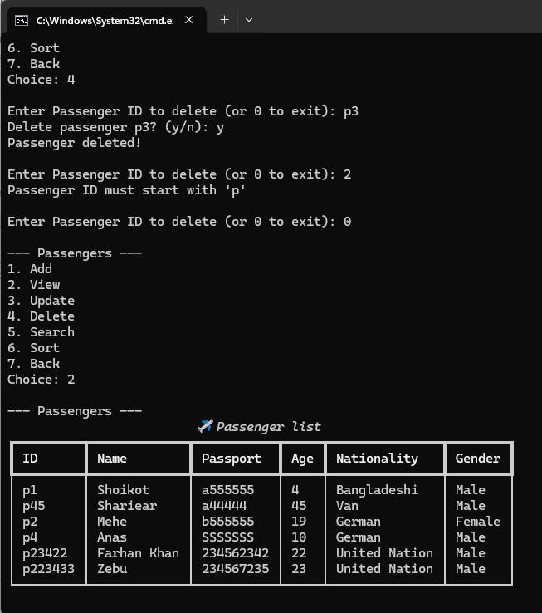

06_view_search_passenger.png

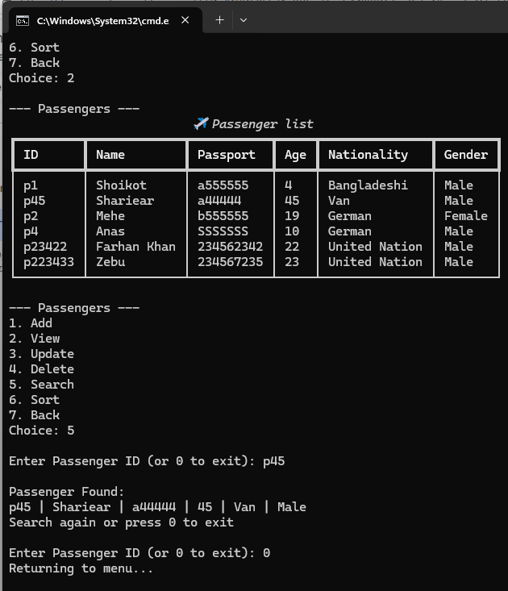

07_view_sort_passenger_details.png

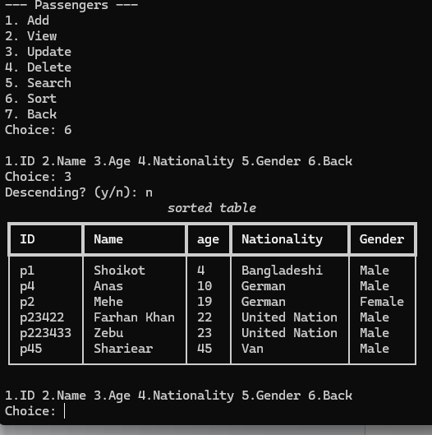

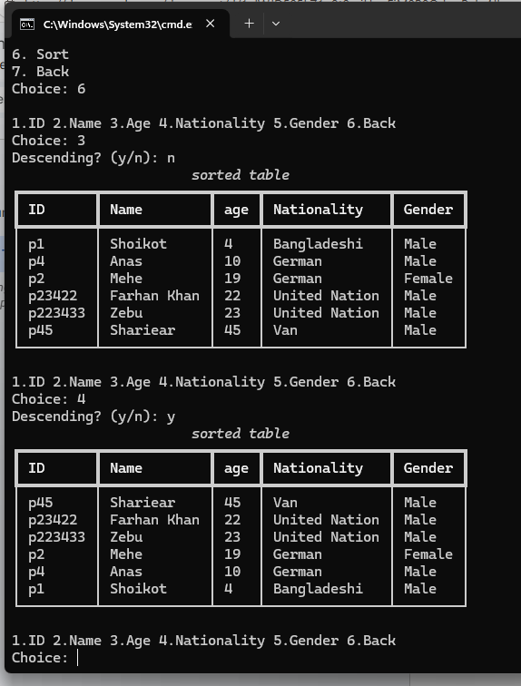

08_view_flight_booking_summary.png

